Speaking Vocabulary

🗣️ What is Speaking Vocabulary
# Source: AI Source: Provided by: [Data Path: Persons Table -> ID Column: 1, Name_En Column: Motasem Essam] -> From: [Chatgpt (GPT-4-turbo)] on [7/30/2025]
Speaking vocabulary includes the words a person actively uses in oral communication. These are the words you can recall easily and use accurately while talking in different situations — from casual conversations to formal speeches.

✅ Key Features:
# Source: AI Source: Provided by: [Data Path: Persons Table -> ID Column: 1, Name_En Column: Motasem Essam] -> From: [Chatgpt (GPT-4-turbo)] on [7/30/2025]
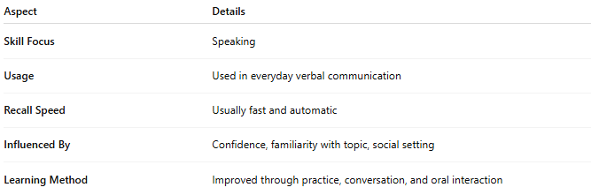
Aspect | Details
Skill Focus | Speaking
Usage | Used in everyday verbal communication
Recall Speed | Usually fast and automatic
Influenced By | Confidence, familiarity with topic, social setting
Learning Method | Improved through practice, conversation, and oral interaction

🧠 Example:
# Source: AI Source: Provided by: [Data Path: Persons Table -> ID Column: 1, Name_En Column: Motasem Essam] -> From: [Chatgpt (GPT-4-turbo)] on [7/30/2025]
- You say: “That’s an excellent idea!”
👉 You actively use the word “excellent” in real-time communication.

👤 Who Uses It?
# Source: AI Source: Provided by: [Data Path: Persons Table -> ID Column: 1, Name_En Column: Motasem Essam] -> From: [Chatgpt (GPT-4-turbo)] on [7/30/2025]
- Everyone — but especially important for:
  - Language learners building fluency
  - Public speakers, teachers, presenters
  - Professionals in meetings or interviews

📌 Related Concepts:
# Source: AI Source: Provided by: [Data Path: Persons Table -> ID Column: 1, Name_En Column: Motasem Essam] -> From: [Chatgpt (GPT-4-turbo)] on [7/30/2025]
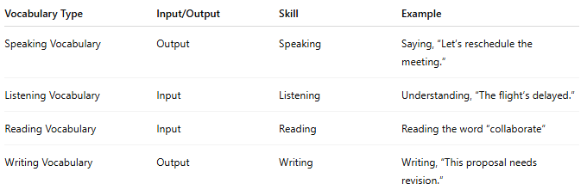
Vocabulary Type | Input/Output | Skill | Example
Speaking Vocabulary | Output | Speaking | Saying, “Let’s reschedule the meeting.”
Listening Vocabulary | Input | Listening | Understanding, “The flight’s delayed.”
Reading Vocabulary | Input | Reading | Reading the word “collaborate”
Writing Vocabulary | Output | Writing | Writing, “This proposal needs revision.”

